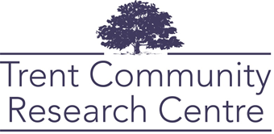

Community-Based Research Project Proposal Form
The following questions will prompt you to provide details about your organization and your proposed research project. Note that this form, once completed, will be kept on record and shared with students and faculty who are interested in working on your project.
If you have questions or would like assistance developing your proposal, please reach out to our team at tcrc@trentu.ca for support from a Project Coordinator.

Lead organization/group/employer:
Organization/group/employer name: Click or tap here to enter text.
Primary Contact Name: Click or tap here to enter text.
Primary Contact Email:Click or tap here to enter text.
Primary Contact Phone: Click or tap here to enter text.
Secondary Contact Name: Click or tap here to enter text.
Secondary Contact Email: Click or tap here to enter text.
Note: The Secondary Contact should be prepared to support student researchers in the event that the Primary Contact is unavailable or unable to support the project once underway.
Organization mailing address: Click or tap here to enter text.
Organization Website: Click or tap here to enter text.
Social media handles: Click or tap here to enter text.
Can we post your logo on our website? ☐ Yes ☐ No

Please answer the following questions:
- Briefly state your organization/group’s purpose and the products or services offered. Click or tap here to enter text.
- Year your organization/group was established:
Click or tap here to enter text.
- How many staff members (including contract workers) work for your organization/group?
Click or tap here to enter text.
- Has your immediate supervisor or board approved this application? If necessary, please provide a name and contact information.
Click or tap here to enter text.

Please identify which Sustainable Development Goals(s) relate to your project (list any numbers that apply, ex. 9, 16, 17): Click or tap here to enter text.

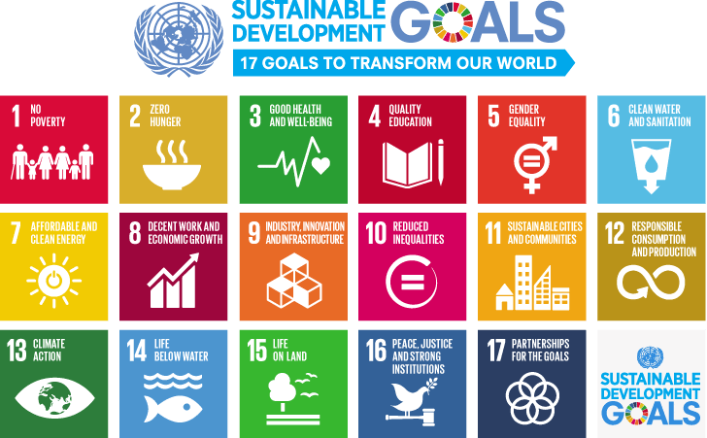

Please estimate the scale of your project (Check any that apply). Note: A single project is typically conducted over a period of 4 or 8 months, depending the volume of work to be undertaken, the need for research ethics, and the availability of the student and/or faculty.
☐ This project could reasonably be completed by one person in a 4-month period.
☐ This project could reasonably be completed by one person in an 8-month period.
☐ This is a large project that may need to continue beyond an 8-month period.
☐ This is a large project that is best undertaken by a group of students.
☐ I am unsure at this time.

Do you anticipate this project or related projects continuing in future years? (Check any that apply)
☐ I prefer that this project be completed as a single undertaking.
☐ I am interested in having this project continue over multiple years.
☐ I will use the results of this project to inform a future proposal.
☐ I am unsure at this time.

Tentative project title: Click or tap here to enter text.

Tell us your project idea
- In 3-5 sentences, please provide a short description of your project and its goals. Note: This description will be used to advertise your project on our website and other media.
Click or tap here to enter text.

- Please provide any additional details regarding the purpose of the project and how will it benefit the social, cultural, environmental and/or economic health of the community?
Click or tap here to enter text.
- What are the proposed research questions to be answered?
Click or tap here to enter text.
- Can you describe what methods might be used to answer the above question(s)? (Check all that apply.)
☐ Academic Literature Review
☐ Grey Literature Review (e.g. Reports, Policy/Legislation, Media, etc.)
☐ Survey
☐ Interviews
☐ Focus Groups
☐ Secondary Data Analysis (Analysis of a pre-existing dataset)
☐ Environmental Scan
☐ Policy Review of Host Organization Documents
☐ Environmental Field Work
☐ Other: Click or tap here to enter text.
☐ I don’t know.

Are there any critical tasks you expect students to complete as part of their research? (e.g. meet with stakeholders, attend an event, etc.)
Click or tap here to enter text.

Please list and describe any important dates for the project (e.g. start and end dates, events, important timelines, fieldwork seasons, etc.).
Click or tap here to enter text.

Please describe how you would like project results to be shared on completion. (check all that apply) NOTE: Please note that the researcher(s) will own the copyright for all work completed as part of his/her involvement, but the lead organization/group/employer may use all project outputs in whole or in part, as it sees fit as long as the researcher(s) is duly credited as the author. If work is completed collaboratively, copyright will be decided by all project participants.
☐ Conference/forum paper or presentation
☐ Manual
☐ Report
☐ Workshop
☐ Presentation
☐ Academic article
☐ Other: Click or tap here to enter text.

Research ethics

Does the research involve human subjects? (e.g. surveys, interviews). NOTE: If yes, the project may be required to submit an application for ethical review of the research. This process may take up to 4-6 weeks and will need to be taken into consideration when creating project timelines.
☐Yes ☐No ☐Unsure

If your project involves collecting human subject data (e.g. interview transcripts), would you like access to that “raw” data at the end of the project? NOTE: If yes, the University Research Ethics Board may require you to complete research ethics training.
☐Yes ☐No ☐ Unsure
If yes, please specify: Click or tap here to enter text.

Does the lead organization/group/employer have policies about research ethics approval?
☐Yes ☐No ☐ Unsure
If yes, please specify: Click or tap here to enter text.

Screening and/or training
- Does your organization require any specific screening or training for student researchers? (e.g. police checks, confidentiality agreements, CPR, WHMIS):
Click or tap here to enter text.
- Will the student(s) be conducting research on site, or working with valuable equipment?
☐Yes ☐No ☐Unsure
If yes, please attach proof of insurance.

Adequate resourcing
- What resources are needed (financial, material, or otherwise) to ensure a successful outcome for the research? (e.g., Travel costs, campaign/promotional materials, digital software tools, tools for fieldwork, lab supplies, specialized training, etc.) Click or tap here to enter text.
- Are there any resources already available to support the research? (e.g. equipment, datasets, etc.) Click or tap here to enter text.

Please explain when project results will be disseminated and made useful to the broader community. If there are special circumstances where results might not be made public, please explain: Click or tap here to enter text.

What Happens Next?
- Review and preliminary matching: Email your proposal along with a completed Due Diligence Checklist to tcrc@trentu.ca.Proposals are reviewed and assessed for alignment with the community-based research expected outcomes criteria outlined below. We will strive to explore any preliminary matches with academic courses, faculty research and students across the university.
- Student application review and first meeting (if applicable): If a student expresses interest in your project, or if a faculty member is interested in connecting your project to a course, TCRC staff will contact you to discuss the best way to initiate the project and will set up a first meeting. NOTE: Your organization has the option to accept or decline students who express interest in your project if you do not feel they have the necessary background or skills.
- Doing the research: Following the matching meeting, all parties will work together to complete a project agreement, insurance forms, budget, etc. so the research can begin!
Community-based research expected outcomes criteria:
- Thorough research is conducted.
- Positive benefits to the social, cultural, environmental and/or economic health of the community are demonstrated.
- Local partnerships are strengthened.
- Students experience is transformative learning that is purposeful.
We Appreciate Your Support!
To raise awareness of the work we do, we ask project partners to publicly acknowledge
our support in print or in-person wherever possible.

